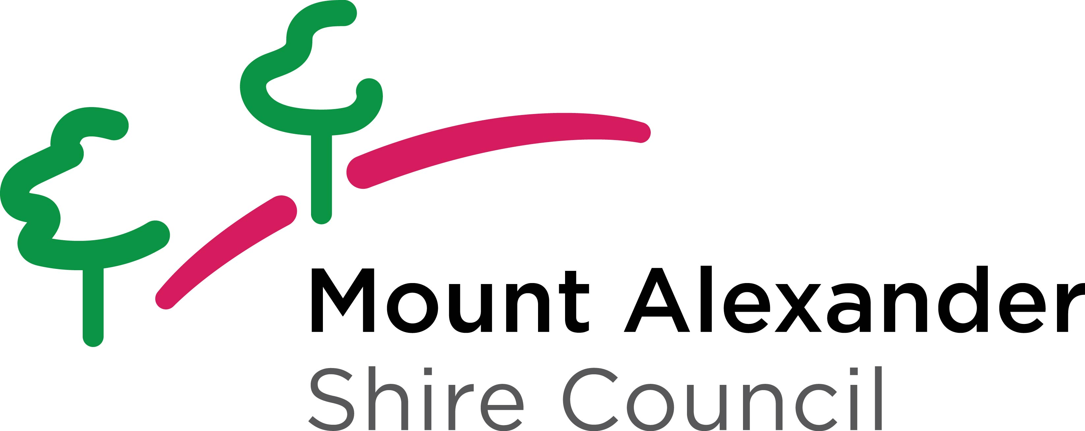
Mount Alexander Shire Council
Auspice Agreement Form
Auspice Agreement Form

Community Grants Program
This Auspice Agreement Form may be used by individuals/unincorporated organisations that are applying for funds though the Mount Alexander Shire Council Community Grants Program.

An auspice agreement formalises the arrangement between an individual/unincorporated organisation (the auspicee) and an incorporated organisation (the auspicor).

It confirms the auspice support being provided by another organisation including the financial responsibilities of the funded project and providing insurance coverage for the project if required.

Individuals or unincorporated applicants are responsible for finding an auspice before start the application process.

Auspicee organisation
Project Name
Auspicor organisation
Auspicor postal address
Incorporation No.
ABN

Declaration
We, the Auspicor, agree to be responsible for the above project on behalf of the Auspicee.
This includes an agreement to:
- Monitor the funded project and ensure it meets the required timelines
- Receipt, bank and administer all funds allocated to the project
- Complete the financial acquittal process for the funded project
- Provide the insurance cover for the project if required

Auspicor contact person
Position
Email
Phone
Signature
Date

